1.2 Workbook
Problems and Fundamental Truths
Key learning’s from video 1.2:

Shift from thinking of ideas as solutions, to understanding problems.

Break down the problems into fundamental truths using first principles thinking.

Scroll down to continue.

Part A: Shifting from ideas as solutions, to thinking about problems
People are more likely to buy something that solves a significant problem for them. If you have/can find a problem that people care a lot about having solved, then it will make marketing and selling your product significantly easier.
If you’re trying to find an idea to take forward then practice identifying problems.
If you already have an idea or vision, then try to figure out the problem that your idea or vision stemmed from.

Action 1: Write down 5 problems you’ve experienced in the last 24 hours, for example:
- We’ve got someone moving into our house, and we need to get a contract sorted and finalise a number of things, but I don’t have time to do it right now.

- I feel stressed because of the number of things that I’ve got on, but I don’t have a highly effective process for organising myself.

- I need to find someone to help out with video editing, Upwork seems like a good solution but sharing such live files is difficult and slows things down.

- I really want to get better at meditating, but I don’t know how to do it in a way that’s effective for me.

List 5 problems:

Scroll down to continue.
Part B: Problems as fundamental truths
The fundamental truths behind your idea are the basic or essential underlying concepts that make the idea valid. If you can break down the problem that’s given rise to your idea into a set of fundamental truths, then you have a better ability to assess the opportunity and build a superior solution.

Action 1: What are the fundamental truths or problems that exist behind your idea(s)?, for example:

Example 1: Fundamental truths behind AirBnB’s concept (as set out in AirBnB’s seed funding round pitch deck)

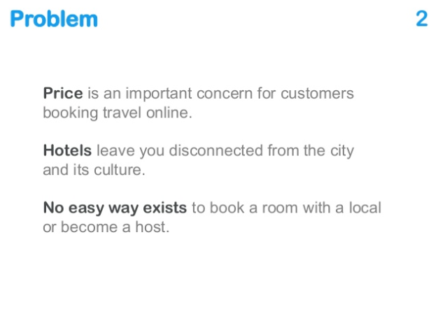
Example 2: Fundamental truths behind the concept of Youtube (as set out in Youtube’s early stage pitch deck)

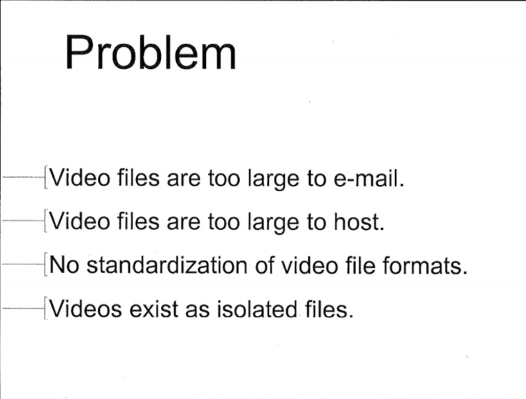

Note: If you don’t have an idea yet, no problem! You can use this frame of thinking with everything you do, as it’s a great way for coming up with better ways of doing things (new ideas).
If you don’t know what the fundamental truths behind your idea are yet, then you’ll learn through market validation (or find that there aren’t any, which might suggest that you need to change course).

List the fundamental truths behind your idea:

End of document.

